Name – Kaung Sat Paing

Student ID – 14399033

Changes -5

Code origin

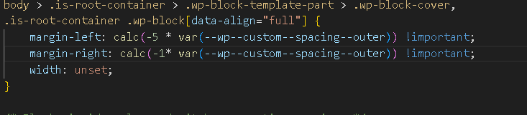

Code Changes

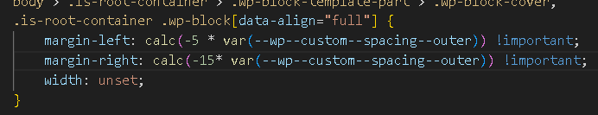

Web Origin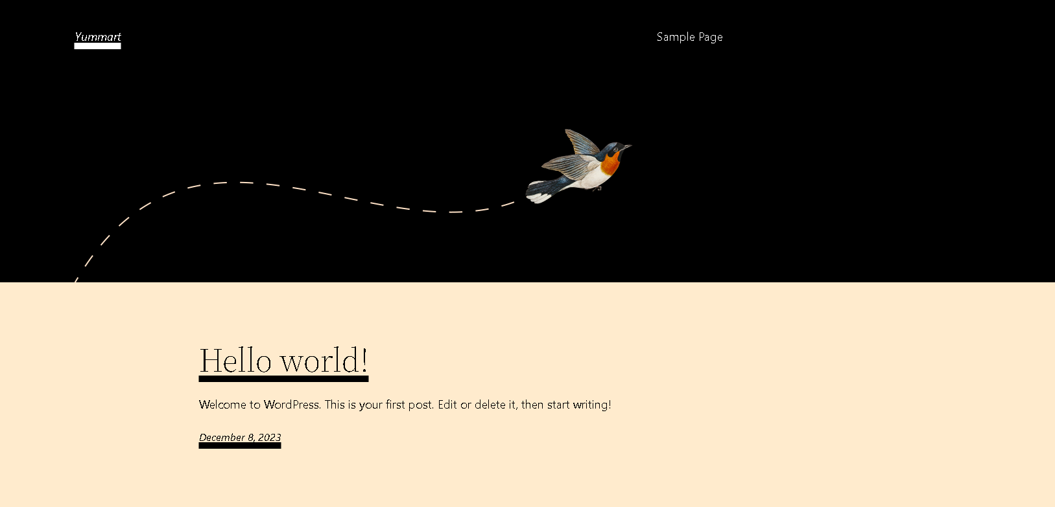

Web Changes

